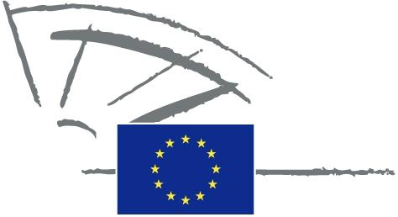
 | EUROPEAN PARLIAMENT | 2014 - 2019

<Commission>{CONT}Committee on Budgetary Control</Commission>

DRAFT AGENDA
INTERPARLIAMENTARY COMMITTEE MEETING
European Parliament - National Parliaments

Towards better spending in shared management:
a more cooperative model of parliamentary scrutiny

Tuesday, 8 November 2016, from 15.00 to 18.30

European Parliament, Brussels

Room: JAN 4 Q 1

Organised with the support for the Directorate for Relations with National Parliaments

Order of business

15.00 - 15.15. Welcome and introductory remarks: Responsibility of the Commission and the Member States in shared management

Ms Ingeborg Gräßle, Chair, Committee on Budgetary Control,
European Parliament

Mr Joachim Zeller, European Parliament rapporteur for the 2015 Commission discharge

Slovak Presidency of the Council

15.15 - 16.15 SESSION I: Shared management: how to balance trust and control?
The effectiveness of national management and control systems and the reliability of the data collected by the Member States

15.15 – 15.25 Member of the European Court of Auditors
15.25 – 15.35 Member of the European Commission
15.35 – 15.45 Member of a National Parliament
15.45 – 16.15 Debate: members of National Parliaments and European Parliament

16.15 - 17.15 SESSION II: Stop to the nonsense of “use it or lose it” Towards a more performance driven approach of spending

16.15 – 16.25 Member of the European Court of Auditors

16.25 – 16.35 European Commission

16.35 – 16.45 Member of a National Parliament or European Parliament

16.45– 17.15 Debate: Members of National Parliaments and European Parliament

17.15 -18.15 SESSION III: A new model of cooperation between the European Union and the Member States’ administrations
17.15 – 17. 25 Member of the European Court of Auditors
17.25 – 17.35 European Commission,
17.35 – 17.45 Member of a National Parliament
17.45 –18.15 Debate: Members of National Parliaments and the European Parliament
18.15-18.30

Closing remarks by Mr Joachim Zeller Rapporteur for the 2015 Commission discharge and Ms Ingeborg Gräßle, Chair, Committee on Budgetary Control, European Parliament.

18.30-19.30 Cocktail reception

