18 April 2016

Special Committee on Tax Rulings and
Other Measures Similar in Nature or Effect (TAXE 2)

Exchange of views with EU National Parliaments

The Anti-Tax Avoidance Package and Other
EU and International Developments: Scrutiny and Democratic Control by National Parliaments

Final List of Participants

National Parliaments

Monday, 18 April 2016, 15.00 - 18.30
József Antall building, meeting room JAN 4Q2

European Parliament
Brussels



BELGIQUE/BELGIE (Belgium)

CHAMBRE DES REPRESENTANTS/
KAMER VAN VOLKSVERTEGENWOORDIGERS
Members:
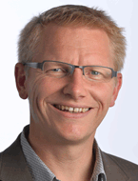 |  | Mr Georges GILKINET  Commission des Finances et du Budget  Ecolo - Greens/EFA
 |  | Mr Peter VANVELTHOVEN  Commission des Finances et du Budget  sp.a - S&D
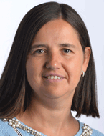 |  | Ms Veerle WOUTERS  Commission des Finances et du Budget  N-VA - ECR

Official:
Mr Tom DE GEETER
Secrétaire, Commission des Finances et du Budget

ČESKÁ REPUBLIKA (Czech Republic)

POSLANECKA SNEMOVNA (Chamber of Deputies)
Members:
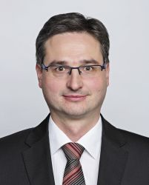 |  | Mr Ondřej BENEŠÍK  Chair, Committee on European Affairs  Czechoslovak People's Party (KDU-ČSL) - EPP

Official:
Ms Eva TETOUROVÁ
National Parliament Representative

SENÁT (Senate)
Member:
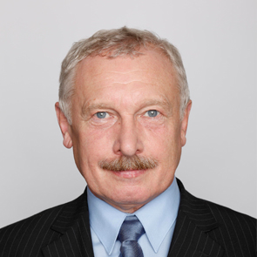 |  | Mr Zdeněk BESTA  Committee on EU Affairs  Czech Social Democratic Party (CSSD) - S&D

Officials:
Ms Dita VOLESKA
Clerk, Committee on EU Affairs
Ms Terezie PÍSAŘOVÁ
National Parliament Representative

DANMARK (Denmark)

FOLKETINGET
Member:
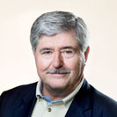 |  | Mr Søren SØNDERGAARD  European Affairs Committee  The Red-Green Alliance - GUE/NGL
Officials:
Mr Klaus ANDERSEN
National Parliament Representative
 |  | Mr Lauge Lukas BISTED PEDERSEN (trainee)

EESTI (Estonia)

RIIGIKOGU
Member:
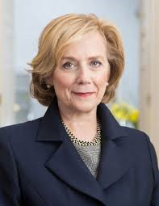 |  | Ms Urve TIIDUS  Finance Committee  Estonian Reform Party - ALDE
Official:
Ms Kristi SÕBER
National Parliament Representative

ΕΛΛΑΔΑ (Greece)

ΒΟΥΛΗ ΤΩΝ ΕΛΛΗΝΩΝ (VOULI TON ELLINON)
Member:
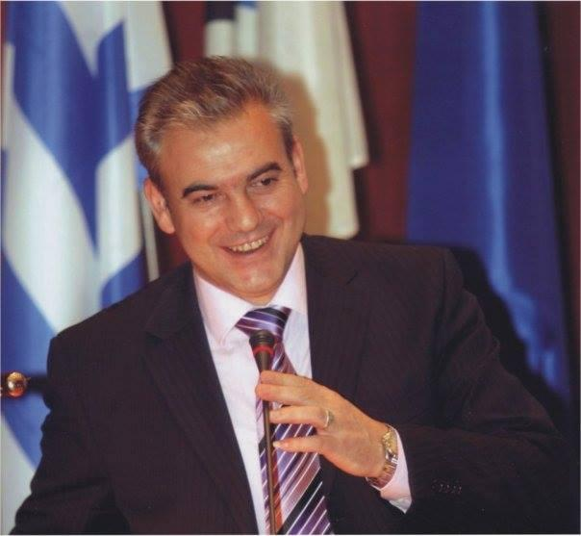 |  | Mr Christos BGIALAS  Chair, Committee on the Financial Statement and the General Balance Sheet and on the implementation of the State Budget  SYRIZA - GUE/NGL

Official:
Ms Despina FOLA
National Parliament Representative

ESPAÑA (Spain)

CONGRESO DE LOS DIPUTADOS
Members:
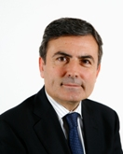 |  | Mr Pedro SAURA GARCÍA  Finance and Public Administration Committee  PSOE - S&D
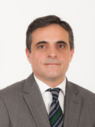 |  | José Vicente MARÍ BOSÓ  Finance and Public Administration Committee  G.P. Popular (GP) - EPP

Officials:
Mr Manuel FERNÁNDEZ-FONTECHA
Legal Adviser, Finance and Public Administration Committee
Ms Carmen SÁNCHEZ-ABARCA
National Parliament Representative

FRANCE

ASSEMBLEE NATIONALE
Members:
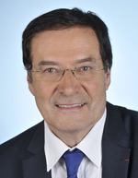 |  | Mr Pierre-Alain MUET  Vice-Président, Commission des finances, de l'économie générale et du contrôle budgétaire  Socialiste, républicain et citoyen - S&D

Official:
Ms Elise VALETOUX
Administrateur, Affaires européennes

ITALIA (Italy)

SENATO DELLA REPUBBLICA
Member:
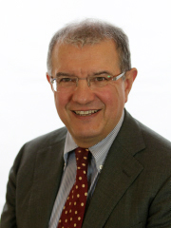 |  | Mr Massimo MUCCHETTI  Chair, Industry, Commerce and Tourism Committee  Democratic Party (PD) - S&D

Official:
Ms Beatrice GIANANI
National Parliament Representative

MAGYARORSZÁG (Hungary)

ORSZÁGGYŰLÉS (National Assembly)
Member:
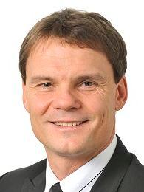 |  | Mr Erik BÁNKI  Chair, Committee on Economics  Fidesz - EPP

Official:
Ms Eva SZEKRENYES
National Parliament Representative

NEDERLAND (The Netherlands)

EERSTE KAMER (Senate)
Members:
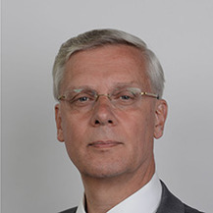 |  | Mr Marnix VAN RIJ  Committee on Finance  CDA - EPP
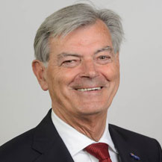 |  | Mr Martin VAN ROOIJEN  Committee on Finance  50PLUS - No Group Affiliation in the EP

TWEEDE KAMER (House of Representatives)
Member:
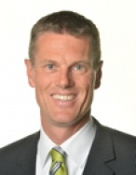 |  | Mr Pieter DUISENBERG  Chair, Finance Committee  VVD - ALDE

Officials:
Mr Jos VAN DE WIEL
Deputy National Parliament Representative
Mr Johan DEKKER
National Parliament Representative Assistant

ÖSTERREICH (Austria)

NATIONALRAT
Member:
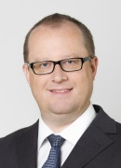 |  | Mr Hubert FUCHS  Vice-Chair, Finance Committee  FPÖ - ENF

Official:
Mr Christian HÜTTERER
National Parliament Representative

POLSKA (Poland)

SENAT
Member:
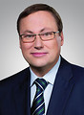 |  | Mr Grzegorz BIERECKI  Chair, Budget and Public Finance Committee  Prawo i Sprawiedliwość - ECR

Officials:
Ms Magdalena SKULIMOWSKA
National Parliament Representative

ROMÂNIA (Romania)

CAMERA DEPUTATILOR (Chamber of Deputies)
Member:
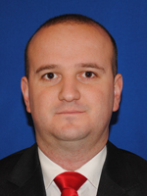 |  | Mr Cătălin TIUCH  Committee for Budget, Finance and Banks  The Parliamentary Group of the Social Democratic Party - S&D

Official:
Mr Tudor DOBRINESCU
National Parliament Representative

SLOVENIJA (Slovenia)

DRŽAVNI ZBOR (National Assembly)
Member:
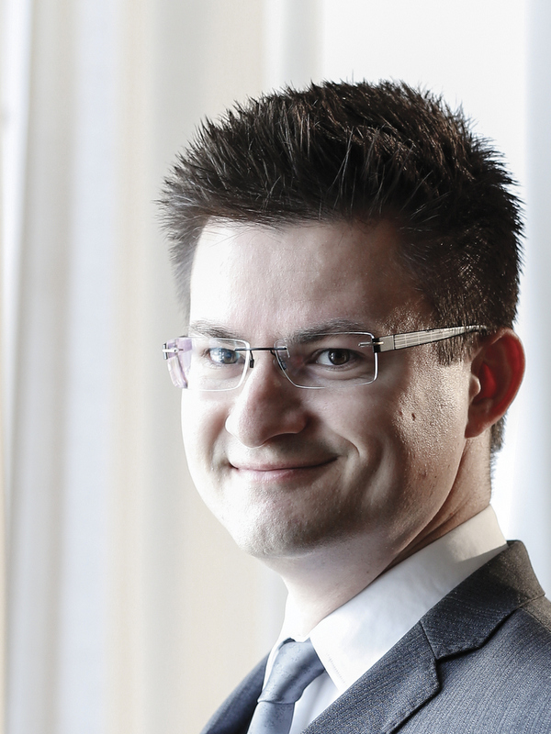 |  | Mr Tilen BOŽIČ  Vice-Chair, Committee on Finance and Monetary Policy  Party of Modern Centre - ALDE

Official:
Ms Romana NOVAK
National Parliament Representative

SUOMI (Finland)

EDUSKUNTA
Member:
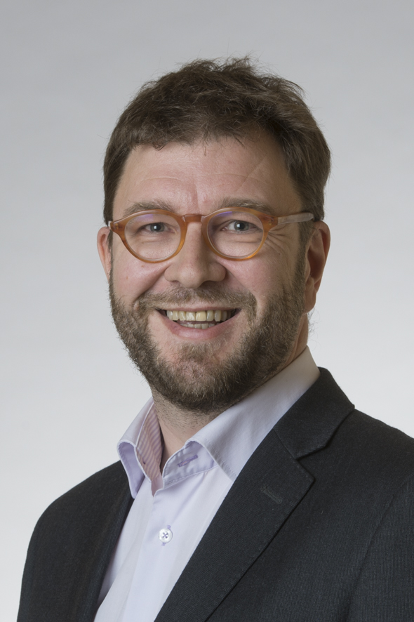 |  | Mr Timo HARAKKA  Finance Committee  Social Democratic Parliamentary Group - S&D

Official:
Ms Satu TUOMIKORPI
Liaison Officer

SVERIGE (Sweden)

RIKSDAGEN
Members:
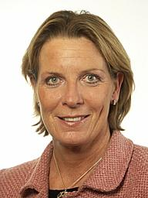 |  | Ms Helena BOUVENG  Committee on Taxation  The Moderate Party - EPP
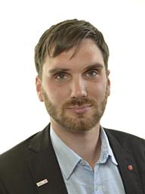 |  | Mr Erik EZELIUS  Committee on Taxation  The Social Democratic Party - S&D
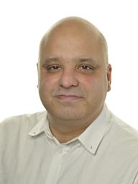 |  | Mr Daniel SESTRAJCIC  Committee on Taxation  The Left Party - GUE/NGL

Officials:
Mr Mikael PYKA
Committee Secretary, Committee on Taxation
Ms Karin BROMS
National Parliament Representative

UNITED KINGDOM

HOUSE OF LORDS
Member:
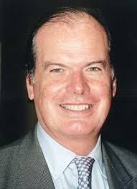 |  | Lord Davies of Stamford  EU Financial Affairs Sub-Committee  Labour Party - S&D

Official:
Mr Paul DOWLING
National Parliament Representative

Officials of Parliaments or Chambers not having a political delegation at the present meeting

DEUTSCHLAND (Germany)
BUNDESTAG

Ms Christine POLSFUSS, Official, Bündnis 90/Die Grünen - The Greens/EFA

Ms Susanne WALDHAUSER, Official, SPD - S&D
Ms Gabriela M. SIERCK, Deputy National Parliament Representative

EIRE-IRELAND
DÁIL ÉIREANN (House of Representatives)

Ms Cáit HAYES, National Parliament Representative

HRVATSKA (Croatia)
HRVATSKI SABOR

Ms Tanja BABIĆ, National Parliament Representative

ΚΥΠΡΟΣ (Cyprus)
ΒΟΥΛΗ ΤΩΝ ΑΝΤΙΠΡΟΣΩΠΩΝ (House of Representatives)

Ms Mary SAVVA, National Parliament Representative

Ms Maria SOTIRIOU GEORGIOU, National Parliament Representative

MALTA
KAMRA TAD-DEPUTATI (House of Representatives)

Mr Kenneth CURMI, National Parliament Representative

POLSKA (Poland)
SEJM

Ms Anna TRĘBACZKIEWICZ, National Parliament Representative

PORTUGAL
ASSEMBLEIA DA REPÚBLICA

Ms Maria João COSTA, National Parliament Representative

ROMÂNIA (Romania)
SENAT

Ms Izabella MOLDOVAN, National Parliament Representative

SLOVENSKO (Slovakia)
NÁRODNÁ RADA (National Council)

Ms Vanda SIPOSOVA, National Parliament Representative

