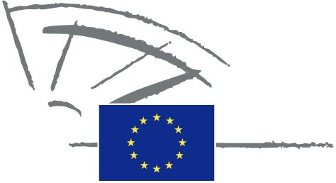
 | EUROPEAN PARLIAMENT | 2014 - 2019

<Commission>{CONT}Committee on Budgetary Control</Commission>

DRAFT AGENDA
INTERPARLIAMENTARY COMMITTEE MEETING
European Parliament - National Parliaments

Towards better spending in shared management:
a more cooperative model of parliamentary scrutiny

Tuesday, 8 November 2016, from 15.00 to 18.30

European Parliament, Brussels

Room: JAN 6 Q 2

Organised with the support for the Directorate for Relations with National Parliaments

Order of business

15.00 - 15.15. Welcome and introductory remarks: Responsibility of the Commission and the Member States in shared management

Ms Ingeborg Gräßle, Chair, Committee on Budgetary Control,
European Parliament

Mr Joachim Zeller, European Parliament rapporteur for the 2015 Commission discharge

15.15 - 16.15 SESSION I: Shared management: how to balance trust and control?The effectiveness of national management and control systems and the reliability of the data collected by the Member States

15.15 – 15.25 Lazaros S. Lazarou Member of the European Court of Auditors
15.25 – 15.35 Rudolf Moegele, Deputy Directorate-General at European Commission, DG Agriculture and Rural Development

15.35 –15.45 Thomas Schmidt, State Minister of Agriculture and environment of Land Saxony

15.45 – 15.55 Kristjan Köljalg, Member of State Budget Control Select Committe, Riigikogu (Estonia)

15.55 – 16.15 Debate: Members of National Parliaments and European Parliament
16.15 - 17.15 SESSION II: Stop to the nonsense of “use it or lose it” Towards a more performance driven approach of spending

16.15 – 16.25 Lazaros S. Lazarou Member of the European Court of Auditors

16.25 –16.35 Nicholas Martyn, Deputy Directorate-General at European Commission, DG Regional Policy

16.35 – 16.45 Eric Van Rompuy Chair of the Committee for Budget and Finances of Belgian Chamber of Representatives,

16.45– 17.15 Debate: Members of National Parliaments and European Parliament

17.15 -18.15 SESSION III: A new model of cooperation between the European Union and the Member States’ administrations
17.15 – 17. 25 Lazaros S. Lazarou Member of the European Court of Auditors
17.25 – 17.35 Martina Dlabajova, Rapporteur for the 2014 Commission discharge
17.35 – 17.45 Olavi Ala-Nissilä, Vice Chairperson of the Audit Committee of the Eduskunta and Former Finnish Member of the European Court of Auditors

17.45 –18.15 Debate: Members of National Parliaments and the European Parliament
18.15-18.30 Closing remarks by Mr Joachim Zeller Rapporteur for the 2015 Commission discharge and Ms Ingeborg Gräßle, Chair, Committee on Budgetary Control, European Parliament.

18.30-19.30 Cocktail reception

