Annex B (of the EGP Statutes)

Membership List

List of the Full Members of the EGP – 31 March 2017
Country | Party | Status
Albania | Partia e Gjelber | Full Member since 2008
Andorra | Verds D'Andorra | Full Member since 2010
Austria | Die Grünen | Full Member since 1993
Belgium | Ecolo | Full Member since 1993
Belgium | Groen | Full Member since 1993
Bulgaria | Zelena Partija Bulgaria | Full Member since 1993
Bulgaria | Zelenite | Full Member since 2013
Cyprus | Cyprus Green Party | Full Member since 1998
Czech Republic | Strana Zelenych | Full Member since 1997
Denmark | Socialistisk Folkeparti / SF | Full Member since 2014
Estonia | Eestimaa Rohelised | Full Member since 1993
Finland | Vihreät - De Gröna | Full Member since 1993
France | Europe Ecologie - Les Verts / EELV | Full Member since 1993
Georgia | Sakartvelo's mtsvaneta partia | Full Member since 1993
Germany | Bündnis 90/Die Grünen | Full Member since 1993
Greece | Oicologoi-Prasinoi / Ecologist Greens | Full Member since 1994
Hungary | Lehet Más a Politika / LMP | Full Member since 2011
Ireland | Comhaontas Glas | Full Member since 1993
Italy | Federazione dei Verdi | Full Member since 1993
Latvia | Latvijas Zala Partija / LZP | Full Member since 2001
Luxembourg | déi gréng | Full Member since 1993
Malta | Alternattiva Demokratika – the Green Party | Full Member since 1993
Moldova | Partidul Verde Ecologist | Full Member since 2008
Netherlands | De Groenen | Full Member since 1993
Netherlands | GroenLinks | Full Member since 1993
Norway | Miljøpartiet De Grønne | Full Member since 1993
Poland | Zieloni | Full Member since 2005
Portugal | Partido Ecologista – Os Verdes | Full Member since 1993
Romania | Partidul Verde | Full Member since 1999
Slovenia | Stranka mladih - Zeleni Evrope / SMS-Zeleni | Full Member since 2006
Spain | Iniciativa per Catalunya Verds / ICV | Full Member since 2006
Spain | EQUO | Full Member since 2016
Sweden | Miljöpartiet de gröna | Full Member since 1993
Switzerland | Grüne / Les Verts / I Verdi | Full Member since 1993
Ukraine | Partija Zelenykh Ukrainy / PZU | Full Member since 1993
United Kingdom | Green Party of England and Wales | Full Member since 1993
United Kingdom | Scottish Green Party | Full Member since 1994

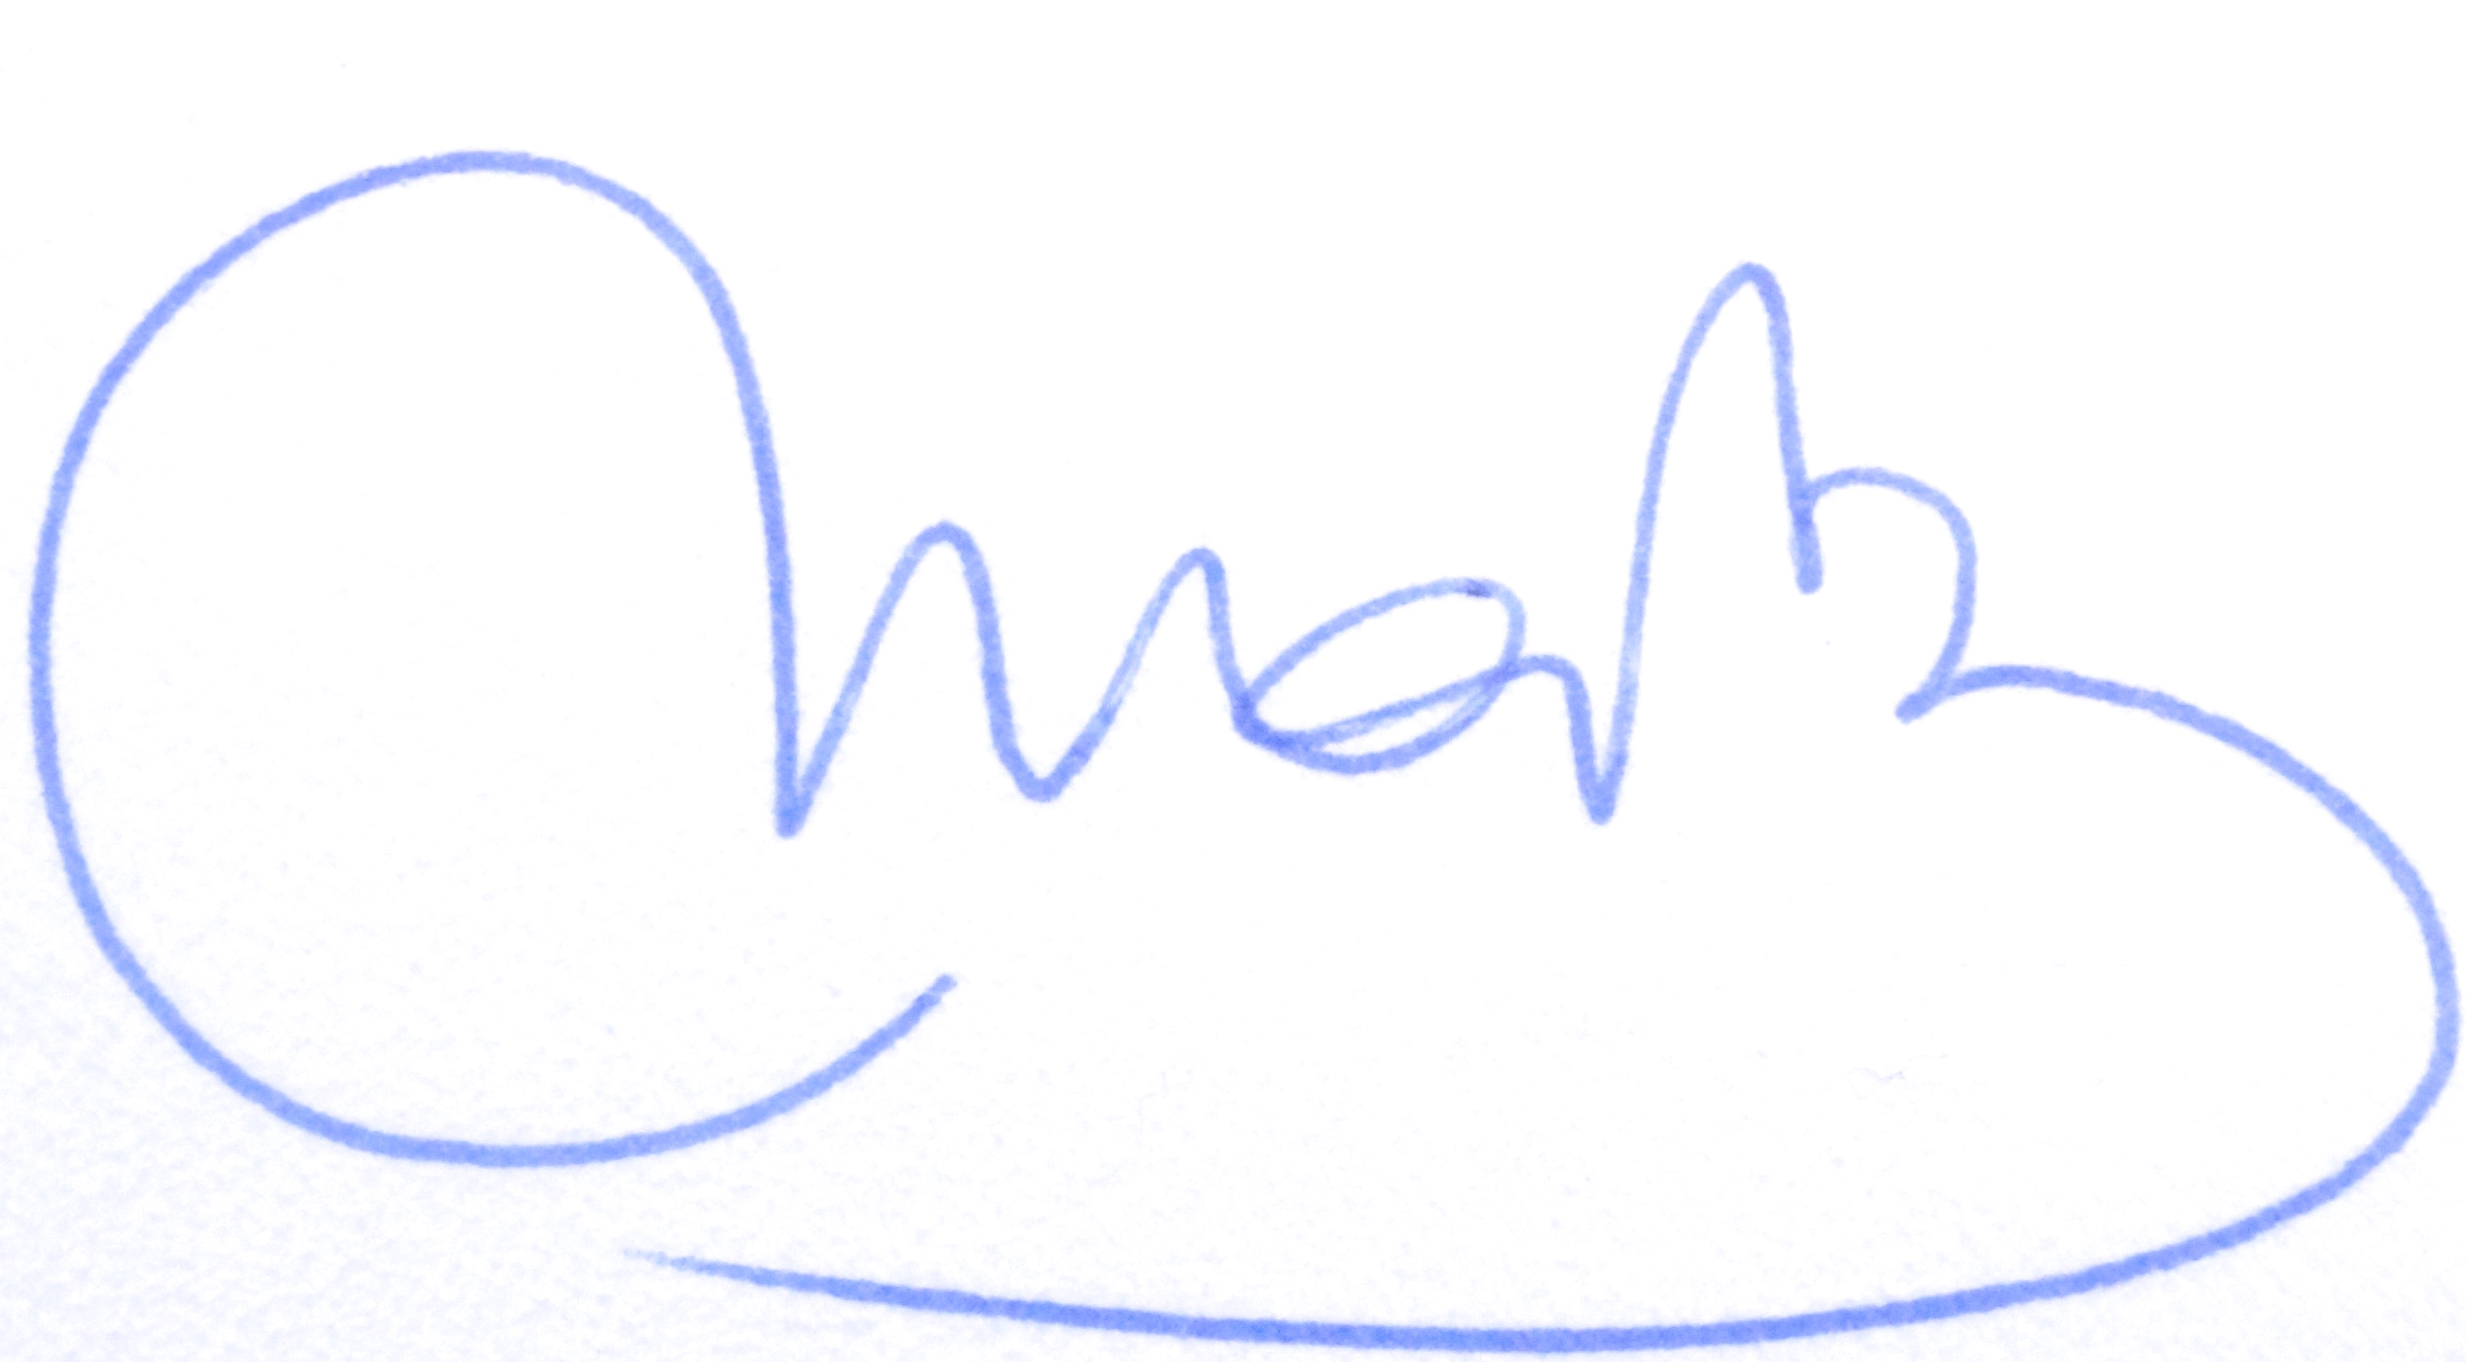

List of Associate Members – 31 March 2017
Country | Party | Status
Azerbaijan | Azərbaycan Yaşıllar Partiyası | Associate member since November 2012
Belarus | Bielaruskaja Partyja "Zialonye" | Associate member since May 2013
Russia | Зеленая Россия / Green Russia | Associate member since May 2013
Russia | GROZA | Associate Member since December 2016

List of Candidate Members – 31 March 2017
Country | Party | Status
Croatia | ORaH | Candidate member since November 2014
Macedonia | Democratic Renewal of Macedonia (DOM) | Candidate member since November 2015
Turkey | Yeşiller ve Sol Gelecek Partisi | Candidate member since November 2012

List of Special Members – 31 March 2017

AUT – Die Grünen, AUSTRIA (3)
Ulrike LUNACEK (indirect MEP)
Michel REIMON (indirect MEP)
Monika VANA (indirect MEP)

BEL – Groen and ECOLO, BELGIUM (2)
Philippe LAMBERTS, ECOLO (indirect MEP)
Bart STAES, Groen (indirect MEP)

DEU – Bündnis 90/Die Grünen, GERMANY (11)
Jan Philipp ALBRECHT (indirect MEP)
Reinhard BÜTIKOFER (indirect MEP)
Michael CRAMER (indirect MEP)
Sven GIEGOLD (indirect MEP)
Rebecca HARMS (indirect MEP)
Martin HÄUSLING (indirect MEP)
Maria HEUBUCH (indirect MEP)
Barbara LOCHBIHLER (indirect MEP)
Ska KELLER (indirect MEP)
Terry REINTKE (indirect MEP)
Helga TRÜPEL (indirect MEP)

DNK – SF – DENMARK (1)
Margrete AUKEN (indirect MEP)

ESP – Iniciativa Catalunya-Verds and EQUO - SPAIN (2)
Ernest URTASUN, Iniciativa Catalunya Verds (indirect MEP)
Florent MARCELLESI, EQUO (indirect MEP)

FIN - Vihreät – De Gröna - FINLAND (1)
Heidi HAUTALA (indirect MEP)

FRA – Europe Ecologie - Les Verts (EELV) - FRANCE (6)
José BOVÉ (indirect MEP)
Karima DELLI (indirect MEP)
Pascal DURAND (indirect MEP)
Yannick JADOT (indirect MEP)
Eva JOLY (indirect MEP)
Michèle RIVASI (indirect MEP)

GBR – The Green Party, England and Wales - UNITED KINGDOM (3)
Jean LAMBERT (indirect MEP)
Molly SCOTT CATO (indirect MEP)
Keith TAYLOR (indirect MEP)

HRV – Independent – CROATIA (1)
Davor ŠKRLEC (direct MEP)

HUN - Lehet Más a Politika and Párbeszéd Magyarországért – HUNGARY (2)
Tamas MESZERICS, Lehet Más a Politika (indirect MEP)
Benedek JÁVOR, Párbeszéd Magyarországért (direct MEP)

ITA – Independent – ITALY (1)
Marco AFFRONTE (direct MEP)

LUX - Déi gréng - LUXEMBOURG (1)
Claude TURMES (indirect MEP)

NLD – GroenLinks – NETHERLANDS (2)
Bas EICKHOUT (indirect MEP)
Judith SARGENTINI (indirect MEP)

SVN - Party Verjamem – SLOVENIA (1)
Igor Šoltes (direct MEP)

SWE - Miljöpartiet de gröna - SWEDEN (4)
Max ANDERSSON (indirect MEP)
Bodil VALERO (indirect MEP)
Linnéa ENGSTRöM (indirect MEP)
Jakop DALUNDE (indirect MEP)

